Computer Networks Lab 3

Name: CAO Xinyang

HDU ID: 20321308

Variant: 14

**1.** **Building a network topology**

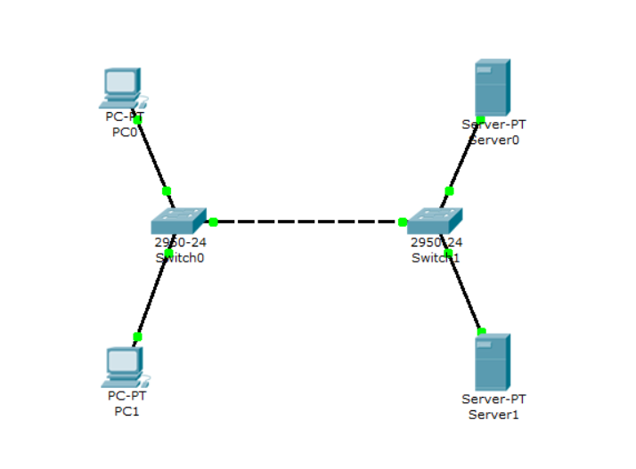

Configure network devices according to the specified parameters:

|  |  |  |  |
| --- | --- | --- | --- |
| Nodes | IP | Mask | IP-address of DNS-server |
| PC0 | 192.168.9.3 | 255.255.255.0 | 192.168.9.6 |
| PC1 | 192.168.9.4 | 255.255.255.0 | 192.168.9.6 |
| Servers | | | |
| Server0 | 192.168.9.6 | 255.255.255.0 | 192.168.9.6 |
| Server1 | 192.168.9.7 | 255.255.255.0 | 192.168.9.6 |

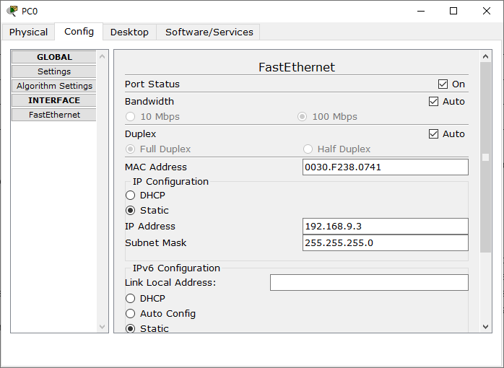 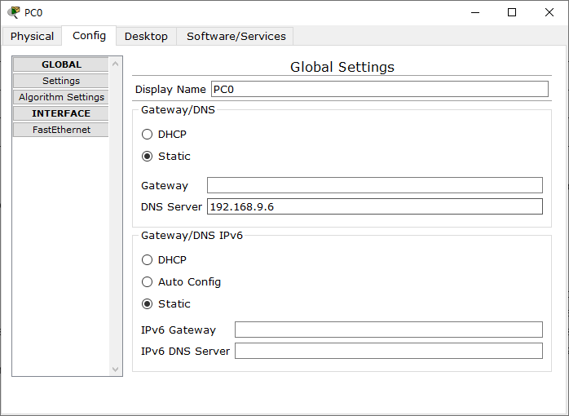

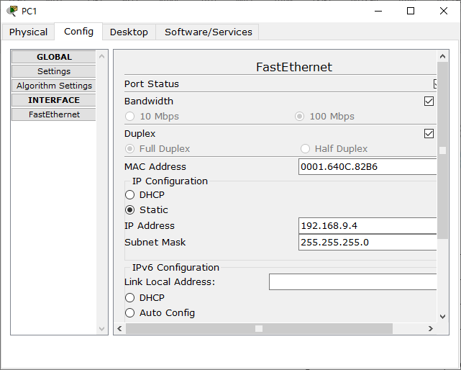 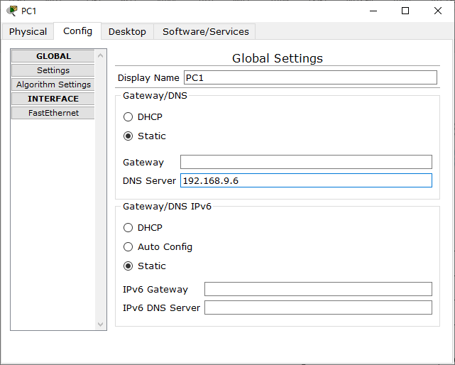

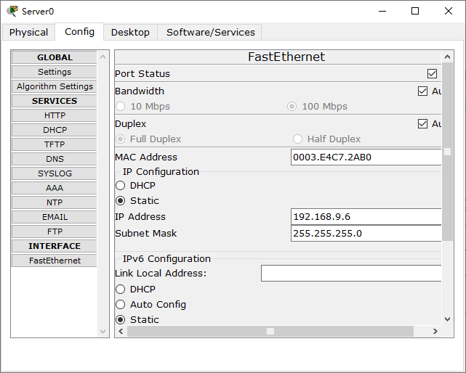 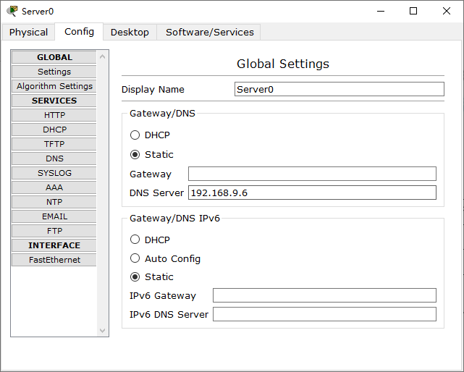

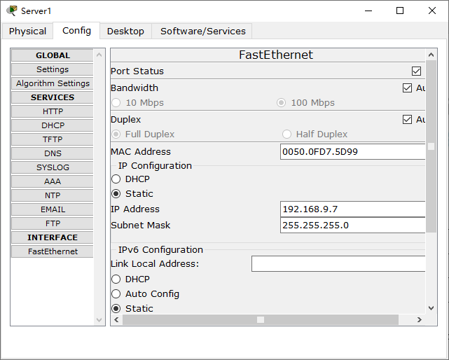 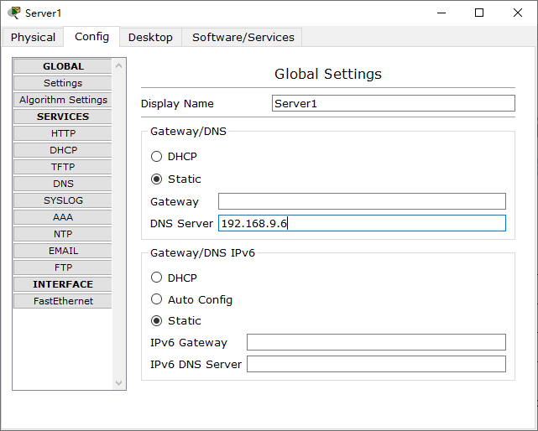

**2. Setting up the mail server**

The email servers are server 192.168.9.6 and server 192.168.9.7.

Connect the DNS service on the server 192.168.9.6:

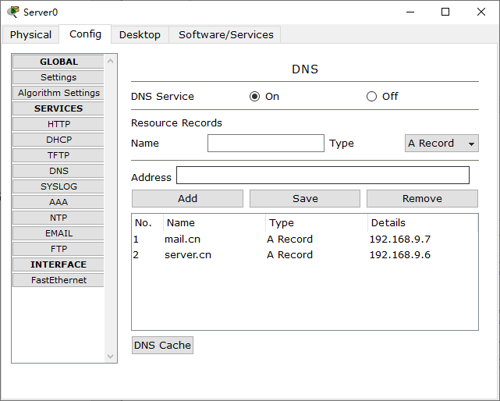

Configure the mail server 192.168.9.6 with smtp and pop3 server support:

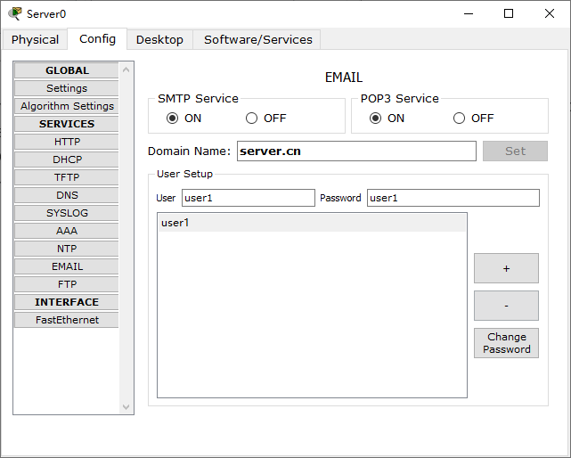

Smtp server and pop3 server on machine 192.168.9.6 are configured, have one registered user. It also supports the DNS service, which has two resource records.

On server 192.168.9.7, you also need to configure a mail server with SMTP and POP3 support. The DNS server for it is 192.168.9.6.

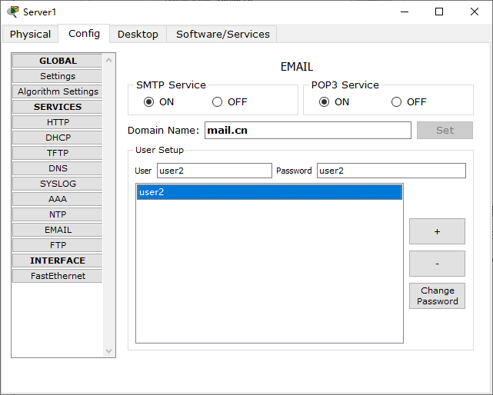

Configuring the mail service on the end nodes

To work with an smtp or pop3 mail server, an email client must be configured on the user's computer, which will interact with the server.

Set up an email client on the host 192.168.9.3:

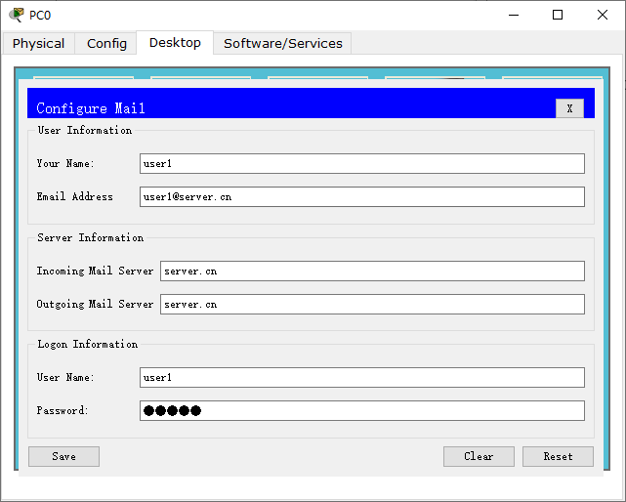

Now the mail service in the domain is available for the user user1 server.cn : sending and receiving emails.

Configure the mail service on the host 192.168.9.4:

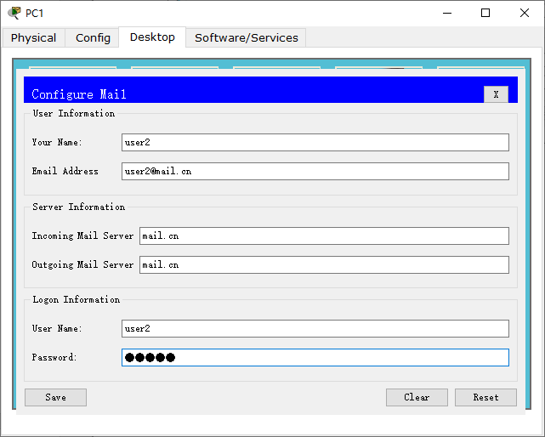

Now the mail service in the domain is available for the user user2 mail.cn : sending and receiving emails.

Configuration of all devices and necessary services is completed.

**3. Research of applied mail protocols in simulation mode**

Switch to the Cisco Packet Tracer simulation mode. Add filters for 2 protocols: SMTP and POP3. This means that packets of only filtered protocols will be displayed on the network.

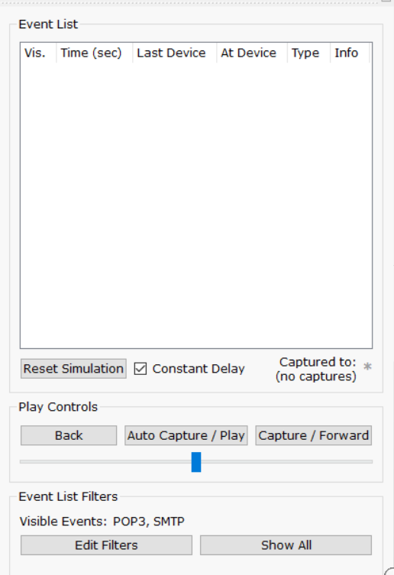

Send an email from host 192.168.9.3 from user1 to host 192.168.9.4 user2:

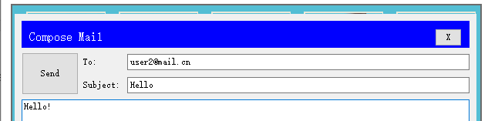

Click on the “Send” button, the sending of the letter will begin.

An SMTP packet has formed on the host 192.168.9.3.

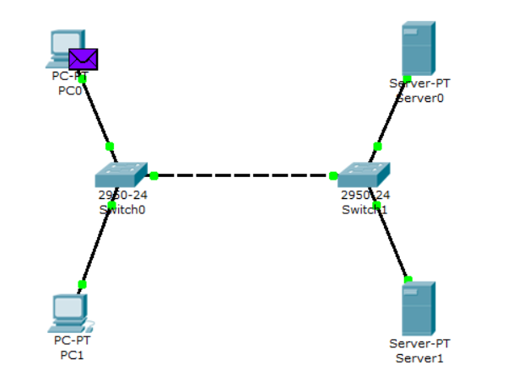

the contents of the package generated on the node:

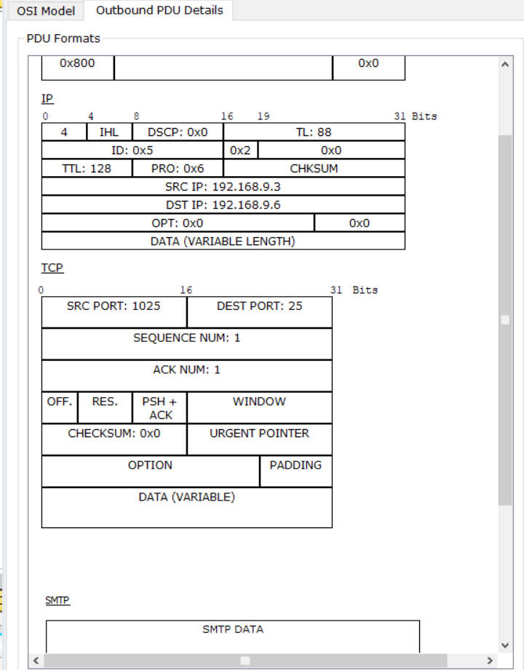

The packet is addressed to the mail server at the IP address 192.168.9.6. The TCP header contains the destination port – 25. It can be concluded that the packet is formed correctly. The packet passes through two switches on its way to the server.

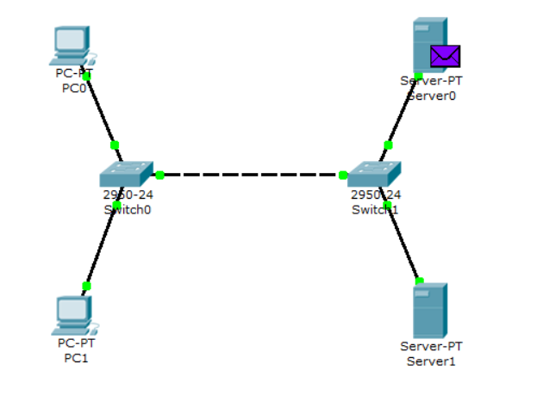

On the server 192.168.9.6, an SMTP response is generated to the client with the IP address 192.168.9.3 and sent to the specified address.

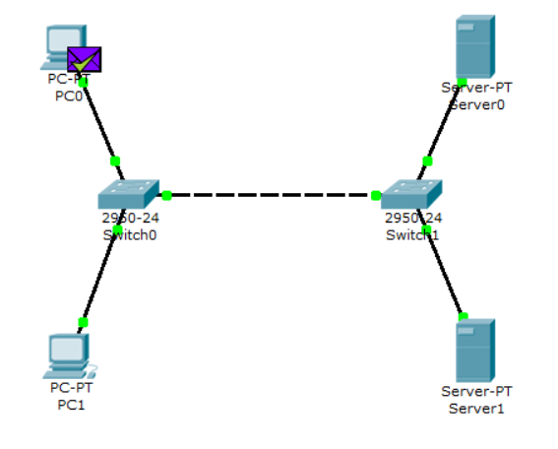

When a packet arrives at the server, the server, processing it, determines that the letter is addressed to the domain mail.cn . Server 192.168.9.6 accesses the DNS service for the IP address of the specified server. At the specified address, the message is redirected to the corresponding mail server.

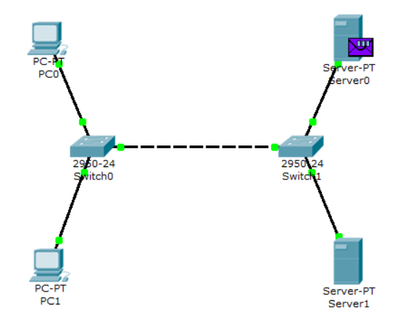

The SMTP packet generated by server 192.168.9.6 contains the following information: destination IP address – 192.168.9.7, destination port – 25

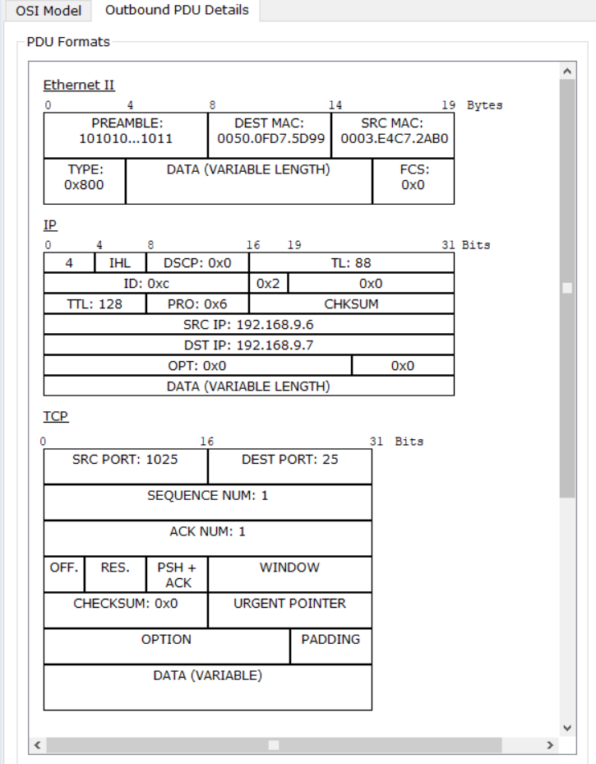

The packet passes through the Switch1 switch and is delivered to the server 192.168.9.7.

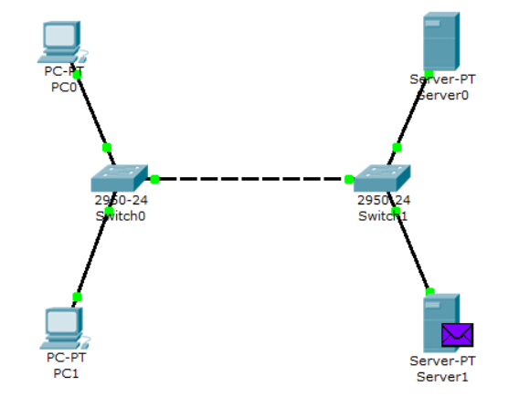

The SMTP response of the server 192.168.9.6 is generated on the server 192.168.9.7 and sent to the specified address

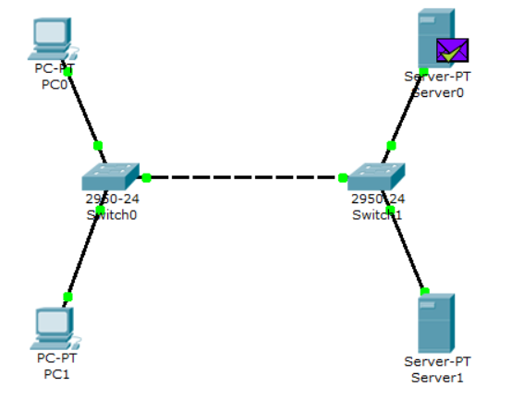

From the contents of the packet that came back to the server 192.168.9.6: source IP address - 192.168.9.7, source port – 25

Using the SMTP protocol, we sent an email to the server mail.cn , it is now stored there.

Our addressee (node 192.168.9.4) has not yet received the sent email, since he has not yet contacted the server via POP3 protocol. To receive a letter, do the following:

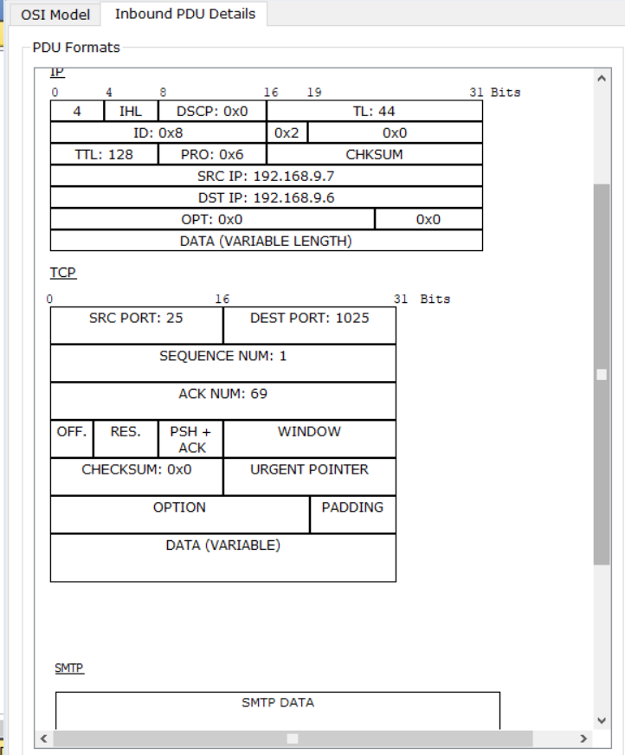

1) One click on node 192.168.9.4.

2) Select the “E-mail” program on the “Desktop” tab.

3) Click on the “Receive” button to read the letter.

A POP3 protocol packet is formed on the host.

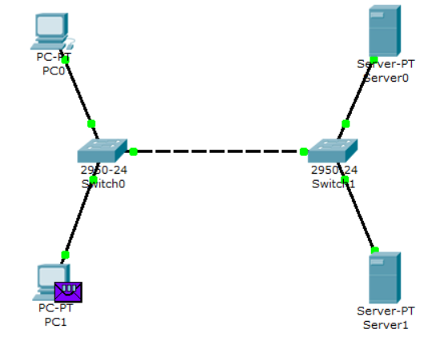

the contents of the package generated on the node

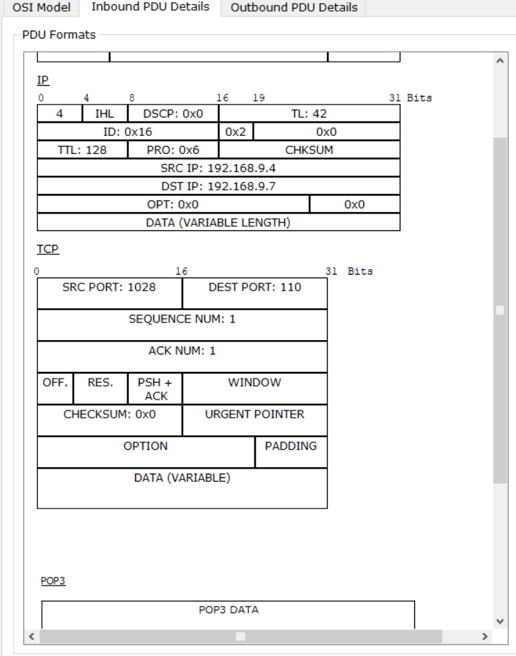

The packet is addressed to the mail server at the IP address 192.168.9.7. The TCP header contains the destination port – 110. It can be concluded that the package is formed correctly. The packet passes through two switches on its way to the server. Make sure this is the case. When a packet arrives at the server, it processes it and forms a response packet

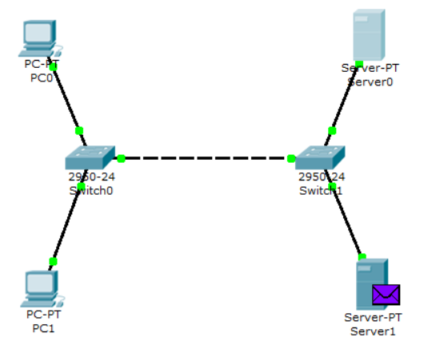

The packet on the same route returns to node 192.168.9.7 with a response (letter) from the server.

the contents of the response

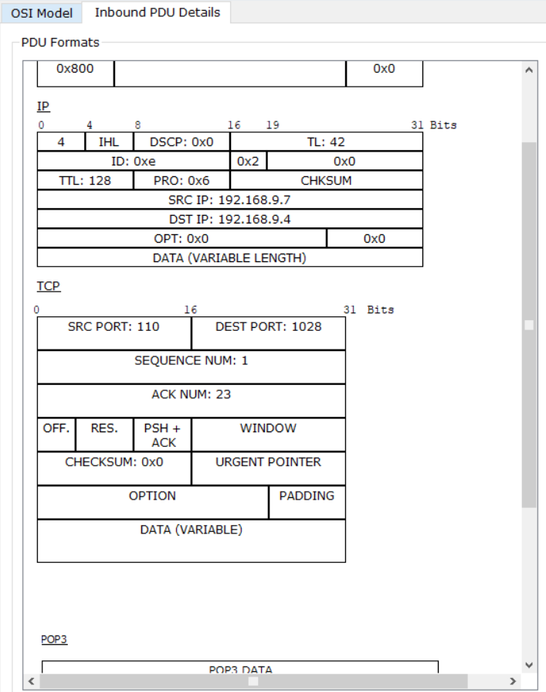

The source port is 110. The response came from server 192.168.9.7 with some POP3 data. Using the POP3 protocol, node 192.168.9.4 received an email from the server sent there by node 192.168.9.3.

